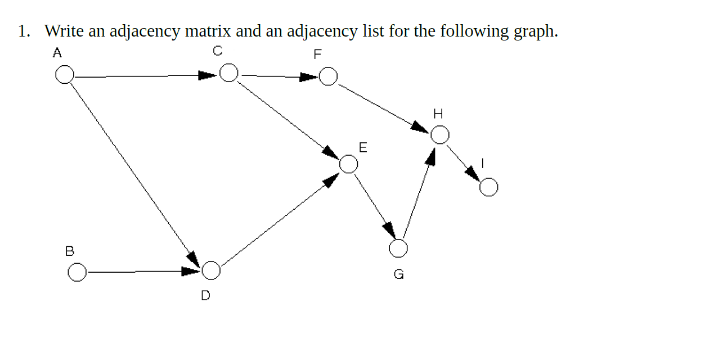

 | A | B | C | D | E | F | G | H | I
A | 0 | 0 | 1 | 1 | 0 | 0 | 0 | 0 | 0
B | 0 | 0 | 0 | 1 | 0 | 0 | 0 | 0 | 0
C | 0 | 0 | 0 | 0 | 1 | 1 | 0 | 0 | 0
D | 0 | 0 | 0 | 0 | 1 | 0 | 0 | 0 | 0
E | 0 | 0 | 0 | 0 | 0 | 0 | 1 | 0 | 0
F | 0 | 0 | 0 | 0 | 0 | 0 | 0 | 1 | 0
G | 0 | 0 | 0 | 0 | 0 | 0 | 0 | 1 | 0
H | 0 | 0 | 0 | 0 | 0 | 0 | 0 | 0 | 1
I | 0 | 0 | 0 | 0 | 0 | 0 | 0 | 0 | 0

Node List
A CD
B D
C EF
D E
E G
F H
G H
H I
I

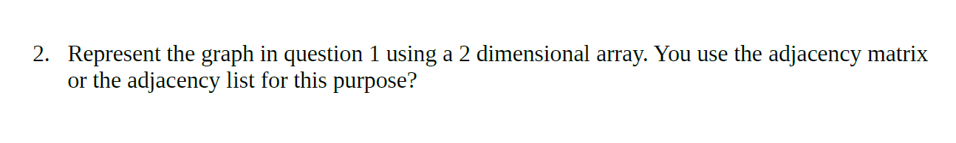

Use adjacency matrix

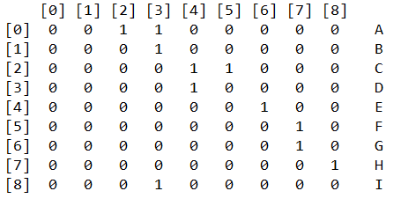

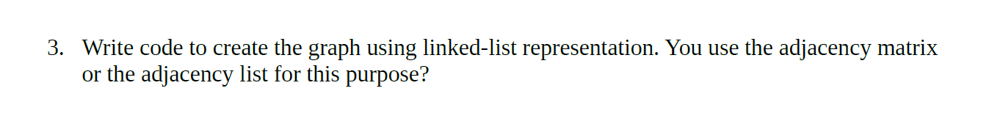
//Use Adjacency list for this purpose

UnweightedGraph<Character> graph = new UnweightedGraph<>();
for (int i = 0; i < 9; i++) { //nine vertex
graph.addVertex((char) ('A' + i));
}
graph.addEdge('A', 'C');
graph.addEdge('A', 'D');
graph.addEdge('B', 'D');
graph.addEdge('C', 'E');
graph.addEdge('C', 'F');
graph.addEdge('D', 'E');
graph.addEdge('E', 'G');
graph.addEdge('F', 'H');
graph.addEdge('G', 'H');
graph.addEdge('H', 'I');

